Consider the following example class.   
PrimeNumbers has three methods.  
The first, computePrimes(), takes one integer input and computes that many prime numbers. iterator() returns an Iterator that will iterate through the primes, and to String() returns a string representation.

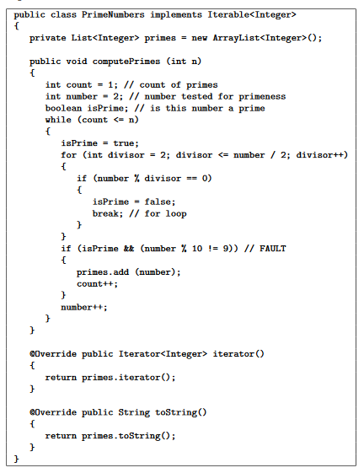

computePrimes() has a fault that causes it **not** to include prime numbers whose last digit is 9 (for example, it omits 19, 29, 59, 79, 89, 109, ...). If possible, describe five tests. You can describe the tests as sequences of calls to the above methods, or briefly describe them in words. *Note that the last two tests require the test oracle to be described*.

1. A test that does not reach the fault: 0
2. A test that reaches the fault, but does not infect: 1-7
3. A test that infects the state, but does not propagate: No tests.
4. A test that propagates, but does not reveal: 8, 10 but test oracle fails to use a correct expectedResult, causing the test to pass
5. A test that reveals the fault: 8, 10 and test oracle uses the correct expectedResult, causing the test to fail

If a test cannot be created, explain why.